* Home
* About
* Activity
* Portfolio
* Reviews
* Contact

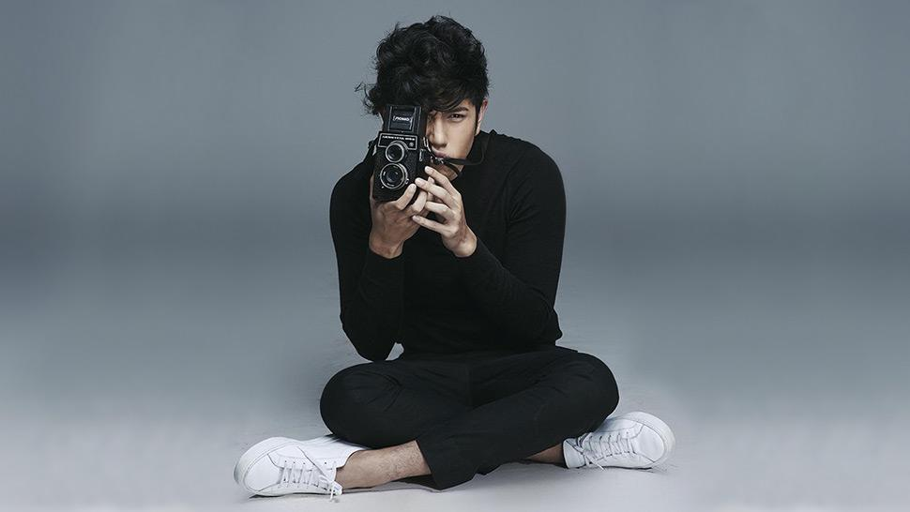

BJ Pascual

Photography & Calligraphy

### "Memories Never Fade Through Photography"

Explore





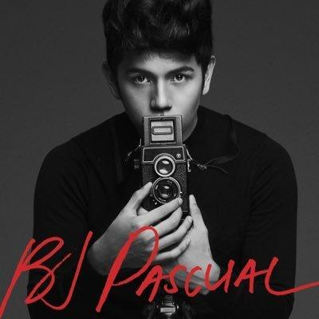

About Us

#### Professional Photographer & Calligraphy Artist

This is owned by Filipino photographer BJ Pascual, one of Manila’s biggest names. He’s the city’s go-to celebrity fashion photographer whose work has featured on countless magazine covers (including this one), high profile advertising campaigns and popular pan-continental TV show, Asia’s Next Top Model. He is also a Calligraphy Artist, that creates an artwork to express himself.

CONTACT

Recent Works





Julia Barreto

Digital Photography





Nadine Lustre

Digital Photography





Kathreen Bernardo

Digital Photography





Liza Soberano

Digital Photography

Portfolios



×

×

×

×



×

×

×

×

Calligraphy Works









People says about BJ Photography & Calligraphy



BJ Pascual is very professional. His photography skills is very amazing. It really impress me during my work together with him and his team. I am looking forward to work more with him.



He is awesome and has an inspirational story that young photographers would admire. His 10 years of experience in the field of photography is very amazing. He is not only a photographer, but also a great calligraphy artist.



I really love how he handled his model. His photography skills and fashion in calligraphy is very inspiring. At the young age, he is already a professional photograher and calligraphy artist, which is very inspiration to other young artist who are hoping to be successful like him in this kind of field.

1.  Jennylyn Mercado
2.  Catriona Grey
3.  Ivana Alawi



Catriona Elisa Gray

@catrionaelisagrey

“I am so grateful to have BJ Pascual as my photographer. He is one of the Philippines' most talented young photographers. His 10 years being in a photography field is such a wonderful and inspirational journey for other young photographer who wants to be like him someday“

Follow

Instagram feed



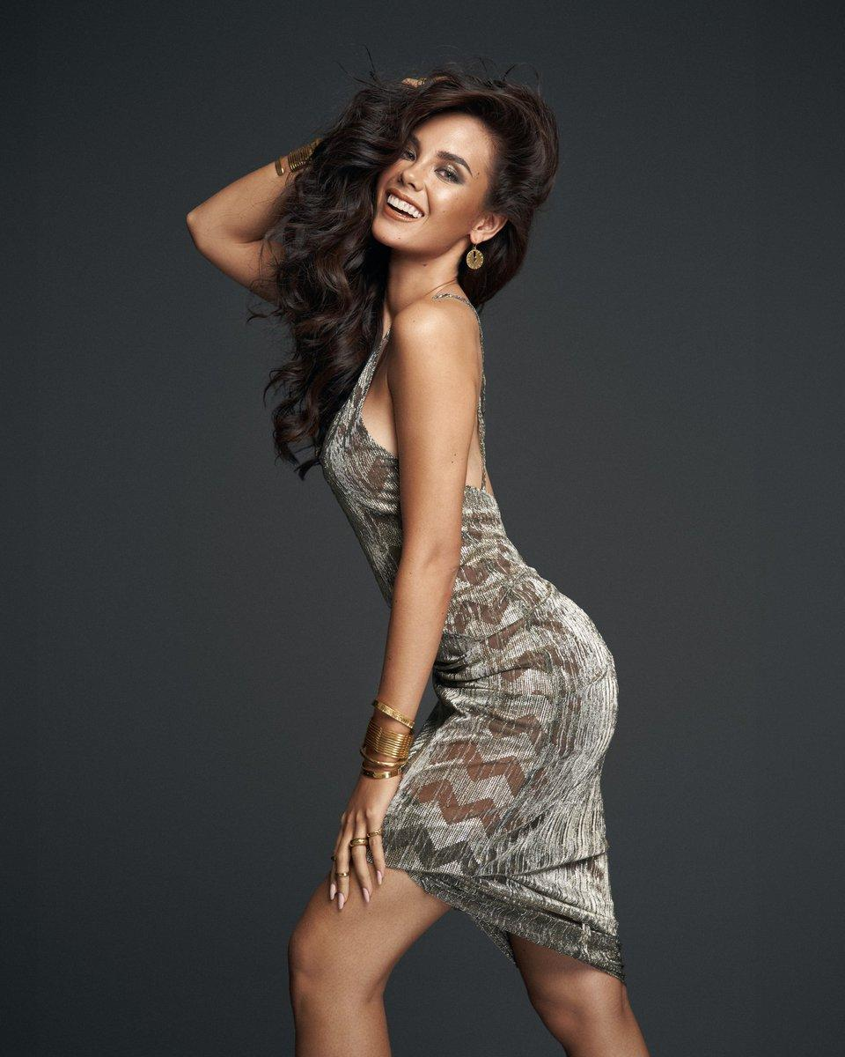

## Find me on social media

* 
* 
* 
* 

Contact me

Send

© 2020 IT ELEC1   |   Design by Rheena Espiritu   |   All rights reserved